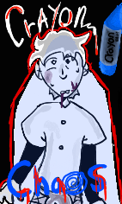

Emanuel Vargas kept the crayon in the back of the kitchen drawer.
Wrapped in an old napkin, buried beneath scissors, batteries, and rubber bands, it sat untouched, but never forgotten.
A single blue crayon.
The paper wrapper was half torn, the tip blunted and misshapen, with faint teeth marks still pressed into the wax. Most people would have thrown it away. Emanuel couldn’t. He told himself he kept it as a reminder. The truth was uglier.
It had been the last thing his son, Jamie, ever touched.
He remembered that day with the cruel clarity that grief carves into memory. Jamie was five, bright, talkative, a little whirlwind in sneakers. It was a Tuesday afternoon. He was coloring at the kitchen table, humming to himself, when Emanuel stepped out to take a phone call. Five minutes, no, maybe three.
When he came back, the hum was gone.
Jamie was on the floor. His face was blue, his small hands clawing at his throat. The crayon, a stupid, bright-blue crayon, was lodged in his windpipe. Emanuel’s hands shook too much to help. By the time the ambulance arrived, the light in Jamie’s eyes was gone.
After the funeral, people told him to “let go,” to “move on.” He nodded, but at night, he’d take out the napkin, unfold it, and stare at the crayon under the kitchen light. He couldn’t throw it away. It was the last piece of his son he had.
But lately, he’d started to hear things.
It began as a faint scraping inside the drawer, like something small shifting against the wood. He ignored it at first. Houses make noise, he told himself. But the sound grew sharper, more deliberate, as if something inside was trying to get out.
One night, just past midnight, the noise woke him again. Tap. Tap. Tap.
Emanuel sat up in bed, pulse thudding. The house was silent except for that steady tapping from the kitchen. He walked down the hall, every step creaking louder than the last.
When he reached the drawer, the tapping stopped.
He hesitated, then pulled it open.
The crayon lay where it always had, but it wasn’t the same. The wrapper was torn further now, the teeth mark deeper, almost fresh. And across the wax, faint but unmistakable, something had been etched into the side: HELLO, DAD.
Emanuel didn’t sleep that night.
He sat at the kitchen table with the drawer open in front of him, staring at the crayon as though his eyes might play tricks if he looked away. HELLO, DAD. The words were carved shallowly into the wax, uneven, like a child’s handwriting. Like Jamie’s.
But that couldn’t be.
He told himself there had to be an explanation. Maybe it had been there all along, a scratch that just happened to look like words. Or maybe he’d done it himself and forgotten, some desperate act of grief in the fog of those first few months.
Still, the letters were too neat. Too deliberate.
He reached into the drawer, fingers trembling, and picked it up. The crayon was cool and smooth, lighter than he remembered. He turned it slowly in his hand, tracing the carved letters with his thumb.
The moment his skin brushed the word Dad, something flickered.
It was faint, like static in the corner of his eye. A shape. A movement. For just an instant, he thought he saw color bleeding up from the wax, a shimmer of blue that pulsed like a heartbeat.
Then it stopped.
Emanuel dropped the crayon back into the drawer, his chest tight. “You’re just tired,” he whispered to himself. “You’re tired, and you’re seeing things.”
But when he looked down again, the crayon had rolled an inch closer to him.
By morning, he’d convinced himself it had been a dream. The house looked normal again in daylight, sunlight cutting sharp lines across the kitchen floor. He made coffee, avoiding the drawer entirely. The sound of the brewing machine filled the silence, ordinary and grounding.
He even laughed once, quietly, at how ridiculous it all was.
But when he sat down at the table with his mug, something caught his eye. On the table, beside the sugar jar, was a streak of blue. Faint, uneven, the same color as that crayon. It trailed across the surface like someone had dragged a waxy finger along it.
Emanuel froze.
He hadn’t taken the crayon out last night. He knew he hadn’t.
He got up, heart hammering, and yanked open the drawer. The napkin was still there, but it was empty.
The crayon was gone.
The first time he heard the voice, it came from the living room. A soft, singsong whisper. Familiar.
“Daddy…”
He turned slowly, breath catching in his throat.
There was no one there. Just the faint smell of wax.
He moved toward the sound, every step heavier than the last. The TV screen flickered faintly, though it wasn’t plugged in, a soft blue glow spilling across the carpet. And then, on the coffee table, he saw it.
The crayon. Standing upright, perfectly balanced on its blunted end.
And beneath it, written in blue wax across the wood:
YOU LEFT ME.
Emanuel’s hands shook. “Jamie?” His voice cracked on the name. “Jamie, is that you?”
The crayon twitched.
Just once, but enough to tip and roll toward him, leaving a smear of blue behind it.
Then came the whisper again. Closer this time. Right behind his ear.
“You let me choke, Daddy.”
Emanuel spun around. Nothing. Just empty space and a whisper that lingered like breath.
The crayon lay motionless again, but he could swear its dull wax body pulsed faintly—as if it were breathing.
And from somewhere deep inside the blue, something laughed.
The laughter deepened, not childish now, but warped, stretched thin like tape run backward. Emanuel staggered back, his knees hitting the edge of the couch. The sound filled the room, layered, one voice crying, another giggling, another screaming, all twisting into the same word.
“Daddy.”
The lights flickered. Blue shadows rippled up the walls, blooming outward from the coffee table like spilled paint. Every framed photo of Jamie—smiling in kindergarten, holding a balloon, wearing that red jacket, began to bleed blue from the edges, the color dripping down the glass like tears.
“Stop,” Emanuel whispered, clutching his chest. “Please, stop.”
The air thickened, humming with static. The crayon rolled off the table and came to rest at his feet. Emanuel stared at it, breathing hard. Then, slowly, it began to move again, not rolling, but dragging itself forward, scraping against the floorboards.
He backed away. The crayon followed.
“Jamie,” he croaked, voice breaking. “I tried to save you. You know I did-”
The whisper cut him off, sharp as glass.
“You left me.”
The blue light surged. The entire room pulsed with it, walls breathing, ceiling bending inward, shadows writhing. Emanuel stumbled into the kitchen, slamming his hand down on the counter, his other reaching for the drawer, for the napkin, for something to contain it, to put it back where it belonged.
But when he yanked the drawer open, the napkin wasn’t there. Instead, the inside was coated in thick, waxy blue. A child’s drawing had appeared on the wood, uneven lines forming a stick figure of a man standing beside a smaller one. The smaller figure had a crayon in its hand. The larger had none.
And both were drowning in blue.
“Daddy…”
The voice came from the hallway now. From Jamie’s old room.
Emanuel turned. The door, untouched for years, stood open, a dull glow spilling out. He could smell the faint sweetness of crayons, that waxy, innocent scent that once filled his son’s laughter.
He stepped forward.
Inside, the room was just as he’d left it, the toys neatly stacked, the little bed made, the nightlight shaped like a moon. Only now, everything was drawn. The furniture, the walls, even the floor, all rendered in heavy, childlike strokes of blue wax. The world itself had become Jamie’s last picture.
At the center of it sat a small figure, cross-legged on the floor, coloring.
Emanuel’s breath hitched. “Jamie?”
The figure turned. Its face was pale and soft, but its eyes were hollow blue circles, wax dripping from their edges. In its tiny hand, it held the same crayon, sharp now, whole, as if it had never broken.
“You came back,” the boy said, voice small and distant, like an echo from under water.
Emanuel fell to his knees, tears spilling. “I never left you, Jamie. I never-”
The boy tilted his head. “Yes, you did.”
Then, before Emanuel could speak, the child pressed the crayon to the air and began to draw. The wax hissed, leaving glowing trails midair, rough, trembling lines that circled around Emanuel like a cage. Each stroke tightened, shimmering, humming louder.
Emanuel tried to move, but the air itself had gone solid. The blue light climbed his legs, freezing him in place. His reflection in Jamie’s eyes began to melt, dripping down his son’s cheeks like wax tears.
“I don’t want to be alone anymore,” Jamie whispered.
The crayon’s glow flared, blinding, searing. The last thing Emanuel saw was his son reaching out to him, a small, wax-slick hand brushing his cheek.
Then everything went still.
When the light finally faded, the room was empty.
Just drawings.
A blue stick figure of a man holding a boy’s hand, both smiling.
Etched into the wall, still warm to the touch.
And on the floor, the crayon lay broken in half.

Epilogue
Two weeks later, the neighbors called the police.
They hadn’t seen Emanuel in days. His car hadn’t moved. Lights flickered on at odd hours—dim blue glows behind drawn curtains—but no one answered the door.
When the officers finally entered, the air inside was heavy with the faint, sweet smell of melted wax. Everything felt… sticky. The floors, the walls—a thin residue of blue smeared across every surface, like fingerprints dragged through paint.
The house was silent.
They found Emanuel’s coffee still on the kitchen table, cold, a thin film rippling across the top. Next to it sat an empty napkin.
One officer noticed the streaks first. Wax marks, bright and childish, trailed from the kitchen down the hall. They followed them to the last door on the left.
Jamie’s room.
Every inch of the room was covered in drawings—overlapping lines of blue, layer after layer of crayon pressed so deep into the walls it had carved grooves in the plaster. Smiling suns. Stick figures. A little boy. A man beside him.
In the center of the floor lay a single blue crayon, snapped in two.
And on the far wall, above the small bed, a final drawing stretched wide across the plaster—simple, but unmistakable.
A man and a child, holding hands, walking into a swirl of blue.
Someone had scrawled words beneath it, jagged and uneven, as though written by a trembling hand:
“We’re together now.”
When the cleanup crew came days later, they painted over the drawings. Three coats of white. But no matter how much they covered, the blue kept bleeding through—faint at first, then darker, spreading like veins beneath the paint.
And sometimes, when the evening sun hit the wall just right, two faint silhouettes could be seen there, a man and a child, holding hands, smiling in a world made entirely of blue.

About the author
T.D Stick
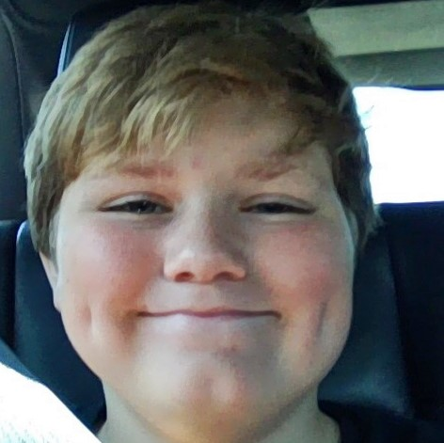

  - T.D Stick lives in Lafayette, Indiana with his mom, dad, little brother, and their playful corgi, Bruno. He’s adopted and proud of the family that surrounds them with love…most of the time :) hehe. When he’s not writing, (which he usually doesn’t) he can usually be found drawing, animating, or curled up with a good book often a manga or a rom-com. He also enjoys playing video games during his free time and finding new ways to have fun with art. Also, he’s trying to be more professional with his writings… ._.
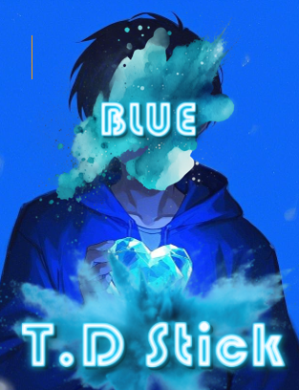
Check out T.D Stick’s other story by going to his website: https://tbarr14.wixsite.com/tdstickbooks
You can e-mail him at tdbarry@icloud.com Blue
Following the character Tio, Blue is a work of art!
Tio is just an average middleschooler. Though little does he know, that this was about to change. During an earthquake Tio finds a blue rock. He keeps it, not knowing what he did will cause his whole life to change. Now he has to fight a man with a chainsaw, and face a mental challenge like no other: He has to escape the government! Follow Tio as he faces all of these in T.D Stick’s first ever story!
Special thanks to my cover artist: Silly_Rusty, he has created the amazing cover you see at the beginning of the story, and Happy Halloween!!!

Reading > iPad kid

